**Premium calculator**

for LIC v1.0

22 November 2015

About: The project “Premium Calculator” is LIC’s maturity premium calculator . Easy to use by any client (an employee of LIC or any policy seeker in the company). The model is very basic. The premium calculated includes new service tax added. Maturity as well as basic requirements are stated.

Features: The first interface includes,

1. Categories of policy provided by the insurance company.

2. Under the categories are the policies displayed for user.

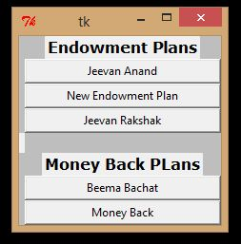

*The above image shows the two categories with the policies they hold.

3. The listed policies are the buttons. The user needs to click the buttons for another interface that calculates the Premium.

For example, if New Endowment Plan is selected;

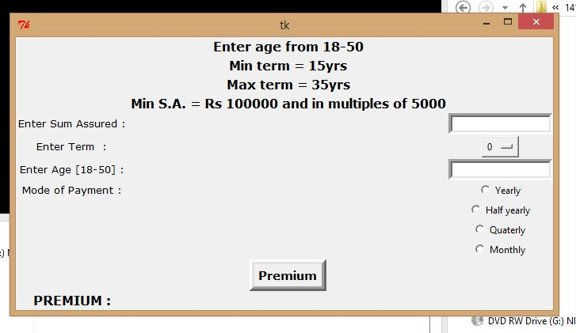

The above shown window will appear.

4. Now user require to input the information as per the instruction.

The information required includes Sum Assured, Term for the policy, Age of the nominee, mode of payment of Premium.

5. The button shown at last which state Premium needs to be clicked after entering the information to view the Premium.

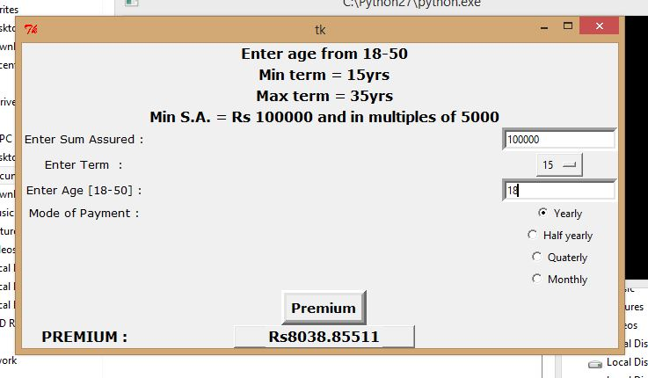

Work Progress:

1. The work done is not fully fledged.
2. Only basics and mostly used policies are covered.
3. The premium calculated is only for first year. The premium from second year onwards may change.
4. Most of the basic requirements are already listed in the project.
5. The project is easy to use, user friendly.

Challenges:

1. For developing a project for an insurance company It needed a thorough idea of working of the company and its plans, which comes under private information of the company
2. Each plan has a different calculation style various other features.
3. There were numerous amount data entries which are must for calculations of premium.

Time required:

1. Only basic and common policies have been covered under these two weeks of working time.
2. 1 and half month more is required to make the project work fully fledged.

Made under guidance of:

Dr. Mahesh Kumar